Kingsmoor Learning Pathway 

**Maths**

* Addition and Subtraction
* Multiplication and Division
* Fractions
* Time
* Length & Perimeter

**Year Group:** 3 Cuba **Teachers:** Miss Donovan

**LSA:** Mrs Everest/Miss Jackson **Term:** Summer

**WOW days/ Key events/**

**Educational visits**

* British Values Week
* Sports Day

**English**

* Persuasive Writing
* Alternative Fairy Tales
* Adventure Stories
* Take One Book – Instruction Writing
* Poetry – Vocabulary building & Poetry appreciation.

**Taste of the Tropics**

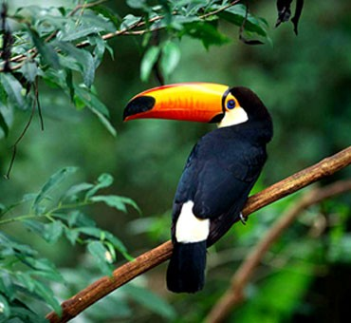

**Science**

**Summer: Plants**

* Identify and describe the functions plants.
* Investigate the way in which water is transported within plants.
* Explore the requirements of plants for life and growth.
* Explore the part that flowers play in the life cycle of flowering plants, including pollination, seed formation and seed dispersal.

**Rocks:**

**•** Compare and group together different kinds of rocks.

• Describe how fossils are formed when things that have lived are trapped within rock

• Recognise that soils are made from rocks and organic matter.

**Geography**

* Identify rainforests on a map (using an atlas).
* Understand different climate zones and they recognise the climate of a rainforest.
* Layers of the Rainforest
* Life in the Rainforest – animals found in the Rainforest.
* The Amazon Rainforest – compare to UK forest.
* Protecting the rainforest – Deforestation.

**Art/Design & Technology**

* To improve their mastery of art and design techniques with a range of materials, including drawing, painting & sculpture.

**International**

* Deforestation in the Amazon
* MFL - Spanish

**PSHE**

Health & Well being

Living in the wider world

**Computing**

**Unit 3.1 We are bug fixers**

* Design, write and debug programs that accomplish specific goals; solve problems by decomposing them into smaller parts.

**Unit 3.5 We are communicators**

* Use technology safely, respectfully and responsibly; recognise acceptable/unacceptable behaviour; identify a range of ways to report concerns about content and contact.

**Home learning**

* Research our KLP and Science Topics
* Weekly Maths, English, SPAG and Spelling homework set on Purple Mash
* Daily reading
* Times Tables Rock stars.

**RE**

Jesus’ teaching and example

Hindu Gods and Goddesses – stories and festivals.