Kingsmoor Learning Pathway 

Year Group: **4**  Teachers:**Mr. Beschizza & Miss Toal** LSA: **Mrs Thomas & Mr Loader** Term: **Summer 1**

**English**

* Recounts (1 week)
* Diary entry (2 weeks)
* Play-scripts (2 weeks)
* Take one book (2 weeks)

**Maths**

* Number multiplication and division (6Weeks)
* Measurement area (1 Week)

**WOW days/Key events/**

**Educational visits**

* Make exploding volcanoes

Natural Disasters: Volcanoes

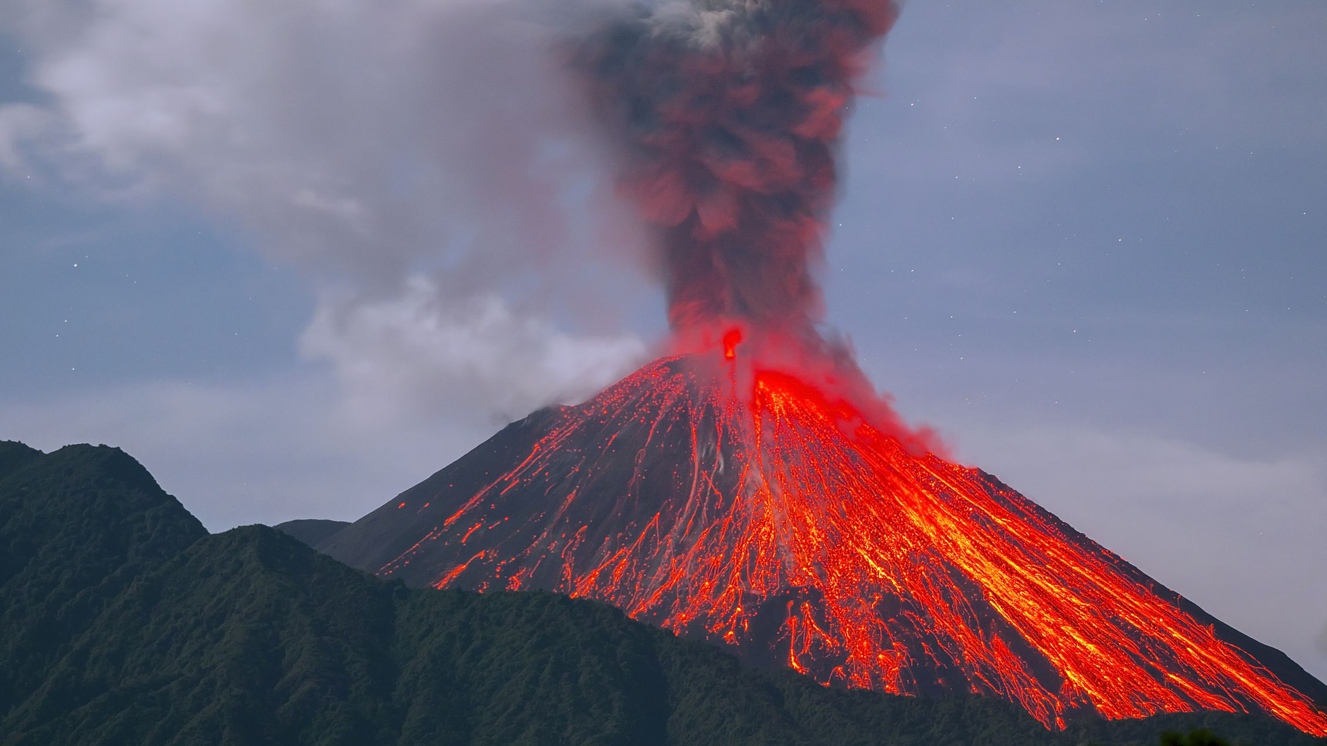

**Geography**

* Identify human and natural disasters.
* Understand the structure of the earth’s layers and location of the tectonic plates.
* Identify and locate major volcanoes
* To describe the structure of a volcano
* Use technical geographical language.
* Research a case study of an active volcano (Etna)

**History**

* Identify historic volcanoes.
* Investigate the volcanic eruption from Pompeii
* Research the Titanic disaster linked to English lesson.

**Science**

Summer 1: States of Matter (3 weeks)

* See SOW
* Make exploding volcanoes

(Experiment)

**Art/Design & Technology**

* Design and create volcanoes (pairs) One child to focus on the inside of the volcano and the other child to focus on the outside. (Sculpture)
* Using mixed media to create a sinking Titanic picture
* Evaluate own work.

**Music**

* Charangha

**International**

* Disasters links with UK.
* Impact on people’s lives

**Home learning**

* Visit the library to research about Volcanoes
* Weekly Maths, English and spelling homework.
* Daily reading

**RE**

Journey to the Promised Land. Judaism

**PSHE**

Health and well being

**ICT**

* Too much information
* We are toy designers