Kingsmoor Learning Pathway 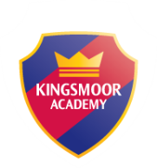

Year Group: **1** Teachers: **Mrs Ashraf**  LSA: **Miss Hart** Term:**Summer**

**English**

* Recount (1 wk)
* Contemporary Fiction (4wks)
* Non chronological Reports (2 wks)
* Instructions (2 wks)
* Poetry (1 wk)
* Take one book (2 weeks)

**WOW days/Key events/ Educational visits**

* Soldiers and Nurses day.
* British values week
* Food tasting linked to the different countries

**Maths**

* Place value
* Measurement (length, height, weight, volume)
* Multiplication and division
* Fractions
* Time (o’clock and half past)

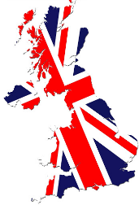

*UK*

**Geography**

* Use simple compass directions (North, South, East and West) and locational and directional language to describe the location of features and routes on a map
* Name and label the four countries of the UK and identify the capital cities of each.

**History**

* History of the UK and meanings behind the names of combined countries.
* History of the British monarchy
* Comparison of different monarchs

.

**Science**

* Summer 1 – plants
* Summer 2 – seasonal changes summer

**Art/Design & Technology**

* Design a crown
* Junk modelling - landmarks

**Music**

* Charangha

**International**

* Comparison to other European countries
* Links to Ghana

**PSHE**

Health and wellbeing & Living in the wider world

Daily exercise/ brain breaks

**ICT**

* We are collectors
* we are story tellers

**RE**

S1- Special ways of living, Christianity with Buddhism

S2- Special places – Christianity with links to Islam

**Home learning**

* Research on the UK
* Weekly Maths, English and spelling homework.
* Daily reading
* **PurpleMash ‘2do’s**