Kingsmoor Learning Pathway 

Year Group: **2 – Egypt**  Teachers: **Miss Carpenter** LSA: **Miss Haigh** Term: **Summer 1 & 2**

**English**

* Stories with recurring language (4weeks)
* Report (3 weeks)
* Vocabulary building (1 wk)
* Poetry (2 wks)
* Take one book (2 weeks)
* Assessment weeks

**Maths**

* Number – Place value Addition & Subtraction
* Statistics – Interpreting data
* Geometry – properties of shapes
* Number – fractions
* SATS revision

**WOW days/Key events/**

**Educational visits**

* Great fire of London day
* Essex County Council Fire Service

**Science**

**Summer 1 & 2:**

* Plants – observe and describe how seeds and bulbs grow into mature plants.
* Find out and describe how plants needs water, light and a suitable temperature to grow and stay healthy.

**Geography**

* Use aerial photographs and plan perspectives to recognise landmarks.
* Identify landmarks in London.

**History**

* Ask & answer questions
* Develop an awareness of the past.
* Identify significant historical events and people.
* Understand historical concepts such as continuity and change.

**London’s Burning**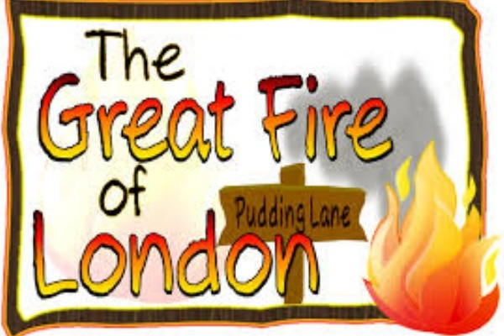

**Art/Design & Technology**

* Use drawing, painting and sculpture to develop ideas.
* Draw famous landmarks of London.
* Evaluate own work.

**Music**

* Charanga

**International**

* Links to class country

**PSHE**

Health & wellbeing & living in the wider world.

**Home learning**

* Visit the library to research about the Great Fire of London.
* Weekly Maths, English and spelling homework.
* Daily reading.
* KLP projects.

**RE**

Special symbols and objects – Sikhism.

Special places – Hinduism.

**ICT**

* We are photographers
* We are researchers