Kingsmoor Learning Pathway 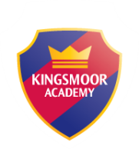

Year Group: Reception/Spain Class

Teacher: Miss Nelmes

LSA: Mrs Griffiths

Term: Summer 1 (1st half term)

**Literacy**

* Wanted Poster
* Adjectives
* Recounts
* Instructions
* Beginning, Middle, End

**Maths**

* Explore numbers to 20 and beyond
* 3D shapes
* First then Now
* Adding more, taking away
* Doubling, sharing, and grouping
* Understanding Patterns

**WOW days/Key events/**

**Educational visits**

Fairy Tales Day-dressing up day

Happily Ever After 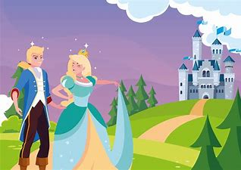

**Key Texts – Traditional Tales**

* Little Red Riding Hood
* The Three Little Pigs
* The Gingerbread Man
* The Three Billy Goats Gruff
* Cinderella

**Understanding the World**

* Floating and sinking (save the Gingerbread man experiment)
* Changes in materials (baking experiment)
* Observing changes in the natural world (Forest Schools)
* Choosing a healthy snack (healthy choices)
* The Senses
* British Values

**Expressive Arts and Design**

* Making own castle -using different materials
* Designing story props
* Design the junk model houses for the three little pigs
* Build different sizes of bridges for three Billy Goats Gruff

**Home learning**

* Phonics, Maths, Creative activities, Science – Purple Mash
* Reading books
* Story from the reading corner

**RE/International**

* Know that there are different countries in the world and talk about the differences they have experienced or seen in photos.
* Ramadan

**PSED**

* Health and wellbeing-discussions
* Understand how others might be feeling

**ICT**

* E-safety