Kingsmoor Learning Pathway 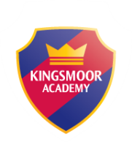

Year Group: Nursery

Teacher: M.Minas/C.Blyth/A.Ciftci

LSA: K.Bond/A.Ismail Term: Summer 1 (1st half term)

**Literacy**

* Blending for Early Reading -CVC words
* Name recognition
* Name writing
* Listening to and retelling familiar stories
* Independent mark making/writing

**Maths**

* Use everyday language to talk about and compare size, length, weight and capacity.
* Experiment with their own symbols and marks as well as numerals.
* Fast recognition of up to 6 objects, without having to count them individually (subitising).
* Understand and use positional language.

**WOW days/Key events/**

**Educational visits**

Traditional Tale Day in Nursery

**Once Upon a Time…**

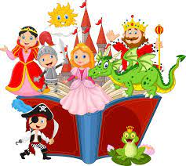

**Key Texts – Traditional Tales**

* The Three Little Pigs
* The Little Red Hen
* The Ugly Duckling
* Jack and the Beanstalk
* The Enormous Turnip
* Goldilocks and the Three Bears

**Understanding the World**

* The Three Little Pigs Investigation: Which material is the strongest?
* Observing changes in the natural world (Forest Schools)
* Making a healthy breakfast (healthy choices)
* Investigation: Who can make the tallest beanstalk? Which material will you use?

**Expressive Arts and Design**

* Create pieces of art using natural objects
* Make a new chair for Baby Bear
* Retell/Role play scenes from Traditional Tales
* Colour mixing – Story scene paintings
* Traditional tale land – Role play area

**Home learning**

* Create a ‘traditional tale’ story box
* Home shared reading challenge
* Make a scene from your favourite ‘traditional tale’
* Home cooking challenge (healthy eating)
* Keep Fit challenge

**RE/International**

* Know that there are different countries in the world and talk about the differences they have experienced or seen in photos.

**ICT**

* E-safety
* Bee bots (link to Maths)

**PSED**

* Circle Time discussions
* Using words to express feelings
* Understand how others might be feeling
* Following classroom rules and routines
* Select resources independently