5J Japan Class Timetable Term: Summer 2021

Kingsmoor Academy

 | 8.45 | 9.00 | 9.30 | 10.20 | 10.30 | 10.45 | 11.00 |  | 12.00 | 1.00 | 1.20 | 3.10
Monday | Registration  Handwriting | Reading  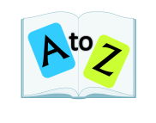 | English | Teaching new handwriting skill | Assembly | Break | Maths  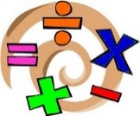 | Maths Meeting | Lunch | KLP / SCIENCE |  | Forest Schools
Tuesday | Registration  Handwriting | Reading | English | Spelling | Assembly | Break | Maths | Maths Meeting | Lunch | KLP / SCIENCE
Wednesday | Registration  Handwriting | Reading | English |  | Spelling | Break | Maths | Maths Meeting | Lunch | Spanish |  | RE / PSHE
Thursday | Registration  Handwriting | Reading | English |  | Assembly | Break | Maths |  | Lunch | PPA  Art |  | PPA  PE
Friday | Registration Handwriting | Reading | English |  | Spelling | Break | Maths |  | Lunch | RE / PSHE |  | Computing

