3I India Class Timetable Term: Summer 2021

Kingsmoor Academy

 | 8.45 | 9.00 | 9.30 | 10.20 | 10.30 | 10.45 | 11.00 |  | 12.00 | 1.00 | 1.20 |  | 3.10
Monday | Registration  Handwriting | Reading  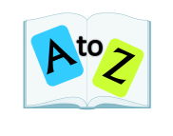 | English | Teaching new handwriting skill | Assembly | Break | Maths  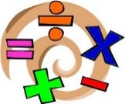 |  | Lunch | PSHE/RE |  |  | KLP / SCIENCE
Tuesday | Registration  Handwriting | Reading | English | Spelling | In class Assembly | Break | Maths | Maths Meeting | Lunch | KLP / SCIENCE
Wednesday | Registration  Handwriting | Reading | English |  | Spelling | Break | Maths | Maths Meeting | Lunch | Mindfulness and Movement |  | SPANISH
Thursday | Registration  Handwriting | Reading | PPA  Art |  | Assembly | Break | PPA  PE |  | Lunch | English |  |  | Maths
Friday | Registration Handwriting | Reading | English |  | Spelling | Break | Maths | Maths Meeting | Lunch | COMPUTING |  |  |  | Reward Time and Next Steps

