Kingsmoor Learning Pathway 

**Maths**

* Multiplication and Division
* Driving multiplication and division facts
* Time
* Fractions
* Length and perimeter

**Year Group:** 3 **Teachers:** Miss Crotty

**LSA:** Miss Clarke **Term:** Spring

**English**

* Take One Book
* Traditional Tales – Fractured Fairy Tales
* Explanation Texts
* Report Writing
* Range of Poetry

**WOW days/ Key events/**

**Educational visits**

Rock circus – visiting school

Visit to Parndon Library

**Rolling Stones**

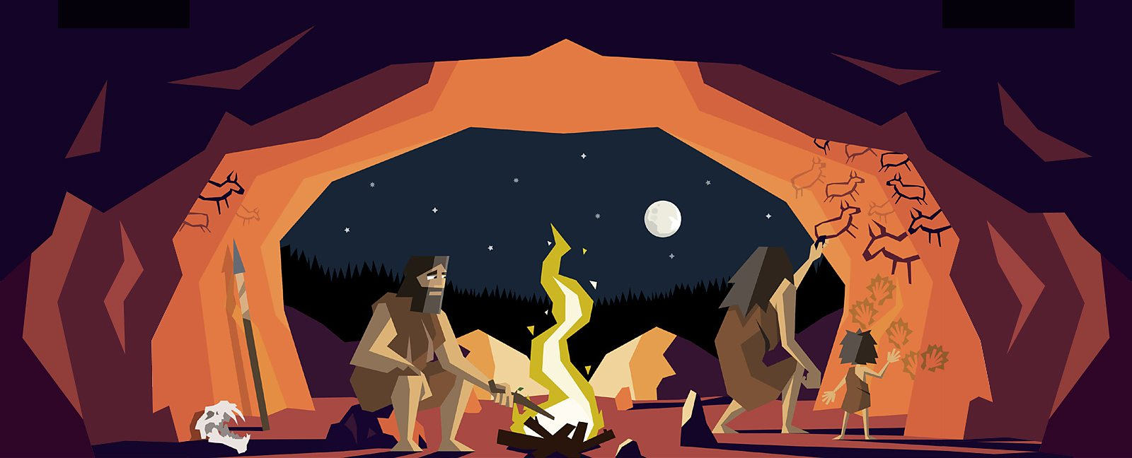

**Science**

**Spring 1: Rocks**

* Compare & group together different types of rocks
* Describe how fossils are formed

**Spring 2: Light**

* Recognise that light is needed in order to see things and that light is reflected from surfaces
* Recognise that shadows are formed when the light from a light source is blocked by a solid object.

**History**

* Place the Stone Age in a historical context.
* Put the events of the Stone Age in chronological order.
* Develop an understanding of the significance of cave paintings.
* Understand how Stonehenge was made and its cultural significance.
* To explain the challenges of early mankind.
* Explore the prehistoric village of Skara Brae.

**Art/Design & Technology**

* To improve their mastery of art and design techniques with a range of materials, including drawing, painting & sculpture.
* **Music - Charanga**
* To learn musical vocabulary – pulse, rhythm, timbre, volume, pitch, dynamics and tempo.
* Bob Marley – Three Little Birds - singing and playing instruments together.

**International**

* Identify where the Stone Age originated from & evidence.

**RE**

* Living as a Christian – The Bible & Prayer
* Jesus’ baptism and the beginning of his ministry

**PSHE**

Relationships & Health and well-being.

**ICT**

|  |  |
| --- | --- |
| **Unit 3.3**  **We are presenters** | **Unit 3.4**  **We are network engineers** |

**Home learning**

* Visit the library to research about The Stone Age to the Iron Age.
* Creative homework project.
* Weekly Maths, English and spelling homework.
* Daily reading