Kingsmoor Learning Pathway 

Year Group: **1** Teachers: **Mrs Ashraf**  LSA: **Miss Norton** Term: **Spring**

**English**

* Recount (1 wk)
* Contemporary Fiction (4wks)
* Non chronological Reports (2 wks)
* Instructions (2 wks)
* Poetry (1 wk)
* Take one book (2 weeks)

**Maths**

* Doubling and halving
* Addition and subtraction
* Odd and even numbers
* Estimating and ordering
* 2D and 3D shapes
* Measuring and comparing
* Sequencing numbers

**WOW days/Key events/**

**Educational visits**

* Soldiers and Nurses day.
* Workshop HOP
* Science week

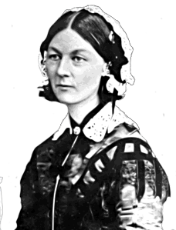

*Fabulous Florence*

.

**Science**

Spr 1: Seasonal Changes (3 wks)

* Describe change in weather in Winter

Spr 2: Everyday materials (3 wks)

* Identify and name everyday materials.
* Science week - WOW science lessons

**Geography**

* Use maps to identify the seven continents and five oceans.
* Identify seasonal changes and make links with the Equator, North and South Poles.
* Use simple compass directions (North, South, East and West) and locational and directional language to describe the location of features and routes on a map

**History**

* Explore the lives of significant individuals who lived in the past, linking to significant individuals in our own lives.
* Develop an awareness of the past, using common words and phrases relating to the passing of time.
* Understand some of the ways in which we find out about the past and identify different ways in which it is represented.

**Art/Design & Technology**

* Florence Nightingale lanterns
* Florence Nightingale Sketches

**Music**

* Charangha

**International**

* Turkey- Identify on map in relation to the UK
* Mary Seacole

**RE**

Christianity with links to Islam & Sikhism

**PSHE**

Relationships & Living in the wider world

**ICT**

* We are treasure hunters

**Home learning**

* Visit the library to research about Florence Nightingale
* Weekly Maths, English and spelling homework.
* Daily reading