1G Ghana Class Timetable Term: Spring 2 2020

Kingsmoor Academy

 | 8.45 | 9.00 |  | 9.30 |  | 10.20 | 10.30 | 10.45 | 11.00 | 12.00 | 1.00 | 1.20 |  | 3.10
Monday | Registration  Handwriting | Reading  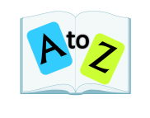 |  | English |  | Maths Meeting | Assembly | Break | Maths  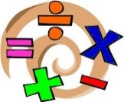 | Lunch | Phonics | Spelling | Teaching new handwriting skill |  |  | Music
Tuesday | Registration  Handwriting | Reading |  | English |  | Maths Meeting | In class Assembly | Break | Maths | Lunch | Phonics | Spelling | KLP / SCIENCE
Wednesday | Registration  Handwriting | Reading |  | English |  | Maths Meeting | Assembly | Break | Maths | Lunch | PPA  PE |  |  |  | PPA  RE / PSHE
Thursday | Registration  Handwriting | Reading |  | English |  |  | Assembly | Break | Maths | Lunch | Phonics | Spelling |  | COMPUTING
Friday | Registration Handwriting | Assembly | Reading |  | English |  |  | Break | Maths | Lunch | Phonics | KLP / SCIENCE |  |  |  |  | REWARD TIME AND FEEDBACK  2.30-3.00

